- Install Prometheus on a server and configure prometheus.yml.

Install Prometheus on Ubuntu Server
We will install:
- Prometheus
- Configure prometheus.yml
- Start service
- Access UI

Step 1: Update server
sudo apt update -y
sudo apt upgrade -y
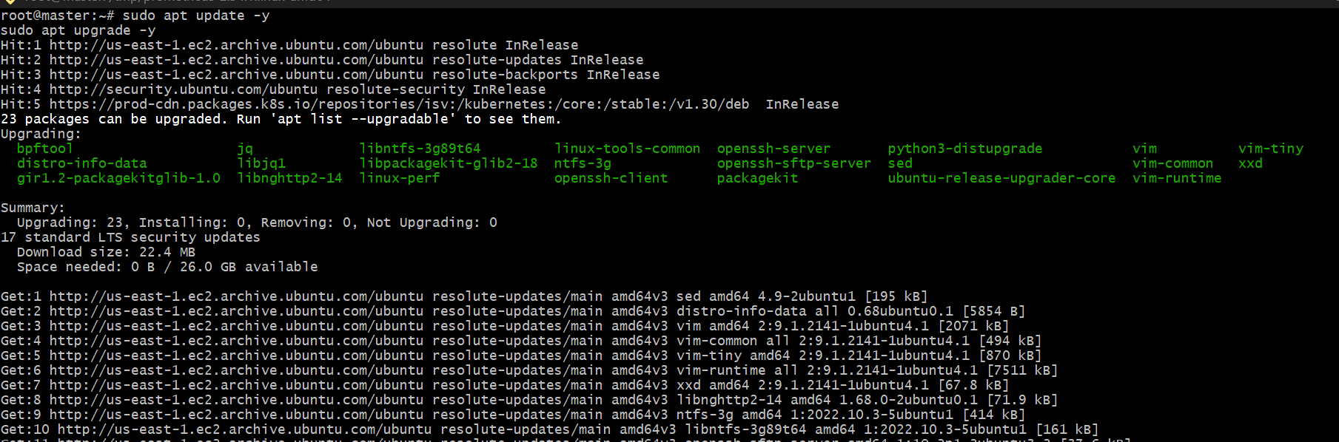

Step 2: Create Prometheus user
sudo useradd --no-create-home --shell /bin/false Prometheus

Step 3: Create directories
sudo mkdir /etc/prometheus
sudo mkdir /var/lib/prometheus
Set ownership:
sudo chown prometheus:prometheus /etc/prometheus
sudo chown prometheus:prometheus /var/lib/Prometheus
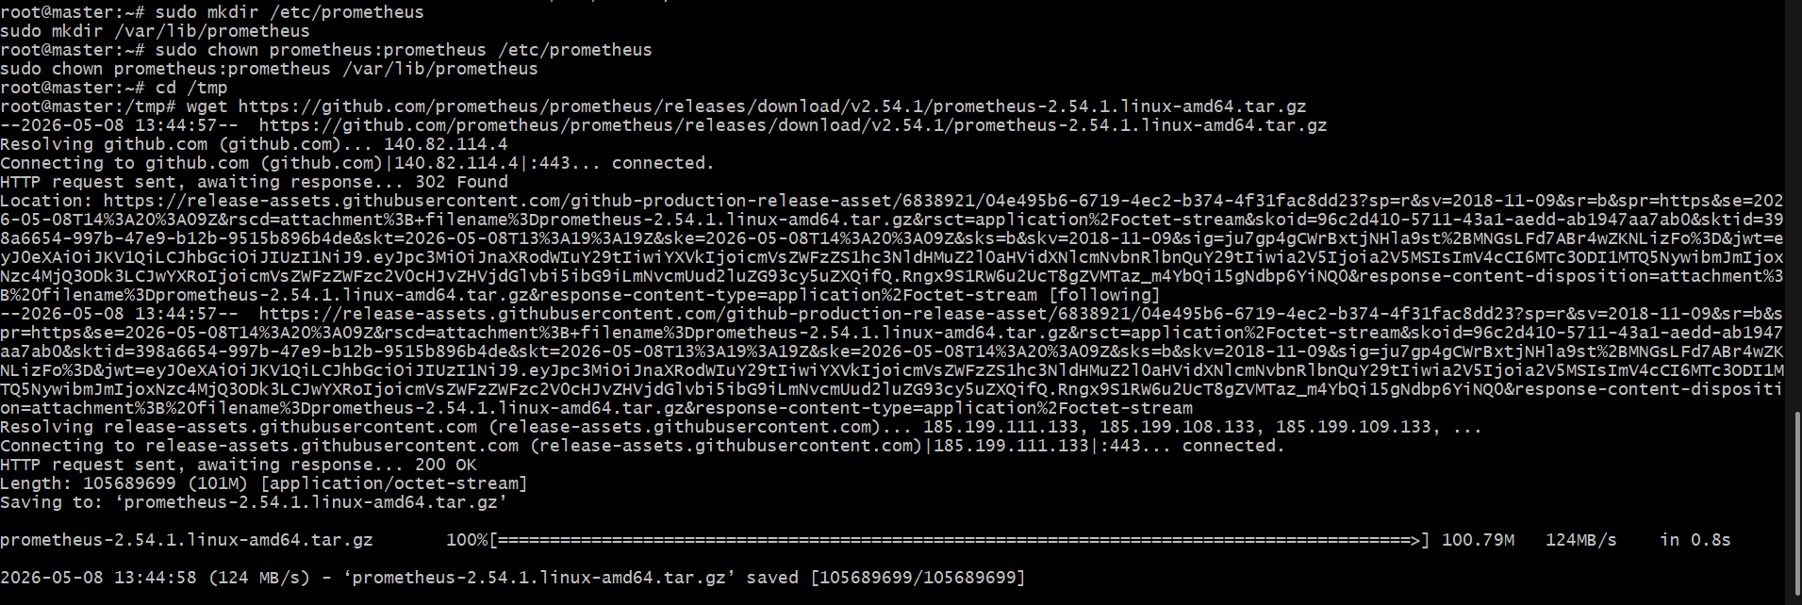

Step 4: Download Prometheus
Go to /tmp:
cd /tmp
Download:
wget https://github.com/prometheus/prometheus/releases/download/v2.54.1/prometheus-2.54.1.linux-amd64.tar.gz
Extract:
tar -xvf prometheus-2.54.1.linux-amd64.tar.gz
Enter folder:
cd prometheus-2.54.1.linux-amd64

Step 5: Copy binaries
sudo cp prometheus /usr/local/bin/
sudo cp promtool /usr/local/bin/
Set ownership:
sudo chown prometheus:prometheus /usr/local/bin/prometheus
sudo chown prometheus:prometheus /usr/local/bin/promtool

Step 6: Copy config files
sudo cp -r consoles /etc/prometheus
sudo cp -r console_libraries /etc/prometheus
sudo cp prometheus.yml /etc/prometheus
Set permissions:
sudo chown -R prometheus:prometheus /etc/prometheus

Step 7: Create Prometheus service
Create service file:
sudo nano /etc/systemd/system/prometheus.service
Paste:
[Unit]
Description=Prometheus
Wants=network-online.target
After=network-online.target
[Service]
User=prometheus
Group=prometheus
Type=simple
ExecStart=/usr/local/bin/prometheus \
--config.file=/etc/prometheus/prometheus.yml \
--storage.tsdb.path=/var/lib/prometheus \
--web.console.templates=/etc/prometheus/consoles \
--web.console.libraries=/etc/prometheus/console_libraries
[Install]
WantedBy=multi-user.target
Save and exit:
CTRL + X
Y
ENTER

Step 8: Configure prometheus.yml
Open config:
sudo nano /etc/prometheus/prometheus.yml
Replace with:
global:
scrape_interval: 15s
scrape_configs:
- job_name: "prometheus"
static_configs:
- targets: ["localhost:9090"]
Save:
CTRL + X
Y
ENTER

Step 9: Reload systemd
sudo systemctl daemon-reload

Step 10: Start Prometheus
sudo systemctl start prometheus
Enable on boot:
sudo systemctl enable prometheus

Step 11: Check status
sudo systemctl status prometheus
You should see:
active (running)

Step 12: Open firewall/security group
Allow port:
9090
AWS Security Group:
Custom TCP
Port: 9090
Source: My IP

Step 13: Access Prometheus
Browser:
http://SERVER_PUBLIC_IP:9090
Example:
http://54.xx.xx.xx:9090

Step 14: Verify targets
In browser:
Status → Targets
You should see:
prometheus = UP
GNU nano 8.7.1 /etc/prometheus/prometheus.yml # my global config global: scrape_interval: 15s # Set the scrape interval to every 15 seconds. Default is every 1 minute. evaluation_interval: 15s # Evaluate rules every 15 seconds. The default is every 1 minute. # scrape_timeout is set to the global default (10s). # Alertmanager configuration alerting: alertmanagers: - static_configs: - targets: # - alertmanager:9093 # Load rules once and periodically evaluate them according to the global 'evaluation_interval'. rule_files: # - "first_rules.yml" # - "second_rules.yml" # A scrape configuration containing exactly one endpoint to scrape: # Here it's Prometheus itself. scrape_configs: # The job name is added as a label job=<job_name> to any timeseries scraped from this config. - job_name: "prometheus" # metrics_path defaults to '/metrics' # scheme defaults to 'http'. static_configs: - targets: ["localhost:9090"] what to replace
Replace the entire file with this clean configuration:
global:
scrape_interval: 15s
scrape_configs:
- job_name: "prometheus"
static_configs:
- targets: ["localhost:9090"]
Save file
Press:
CTRL + X
Then:
Y
Then:
ENTER
Restart Prometheus
sudo systemctl restart prometheus
Check status
sudo systemctl status prometheus
Access in browser
http://YOUR_PUBLIC_IP:9090
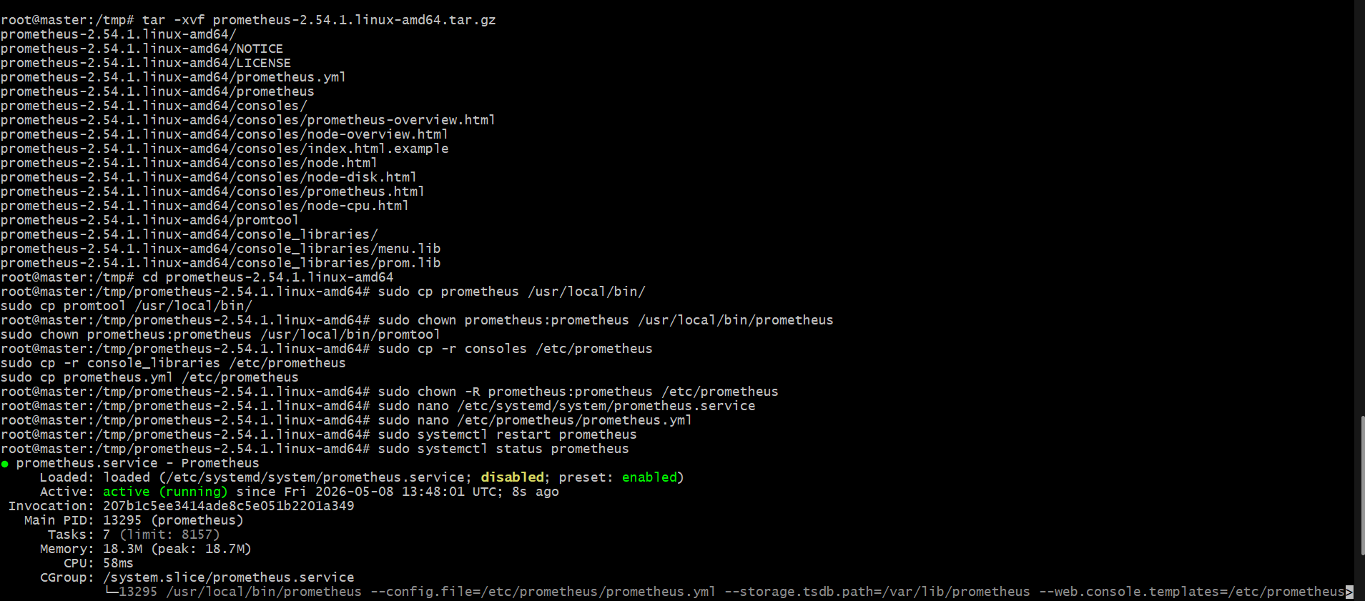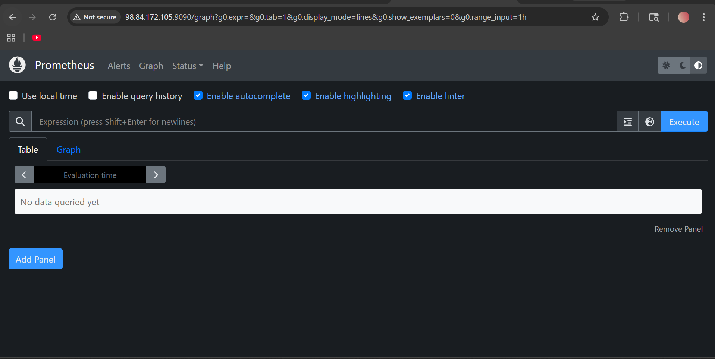

- Install and configure Node Exporter for system monitoring.

Install Node Exporter on Ubuntu Server
Node Exporter collects:
- CPU metrics
- Memory metrics
- Disk metrics
- Network metrics
Prometheus will scrape these metrics.

Step 1: Create node_exporter user
sudo useradd --no-create-home --shell /bin/false node_exporter

Step 2: Download Node Exporter
Go to /tmp
cd /tmp
Download:
wget https://github.com/prometheus/node_exporter/releases/download/v1.8.2/node_exporter-1.8.2.linux-amd64.tar.gz
Extract:
tar -xvf node_exporter-1.8.2.linux-amd64.tar.gz
Go inside:
cd node_exporter-1.8.2.linux-amd64
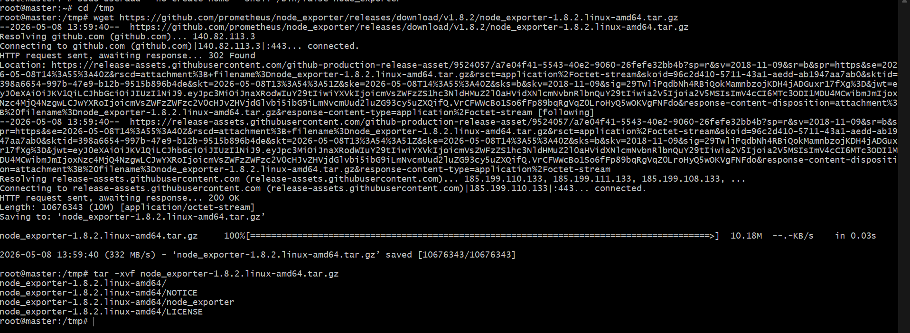

Step 3: Copy binary
sudo cp node_exporter /usr/local/bin/
Give permissions:
sudo chown node_exporter:node_exporter /usr/local/bin/node_exporter

Step 4: Create systemd service
Create file:
sudo nano /etc/systemd/system/node_exporter.service
Paste:
[Unit]
Description=Node Exporter
Wants=network-online.target
After=network-online.target
[Service]
User=node_exporter
Group=node_exporter
Type=simple
ExecStart=/usr/local/bin/node_exporter
[Install]
WantedBy=multi-user.target
Save:
CTRL + X
Y
ENTER

Step 5: Reload systemd
sudo systemctl daemon-reload

Step 6: Start Node Exporter
sudo systemctl start node_exporter
Enable on boot:
sudo systemctl enable node_exporter

Step 7: Check service
sudo systemctl status node_exporter
You should see:
active (running)
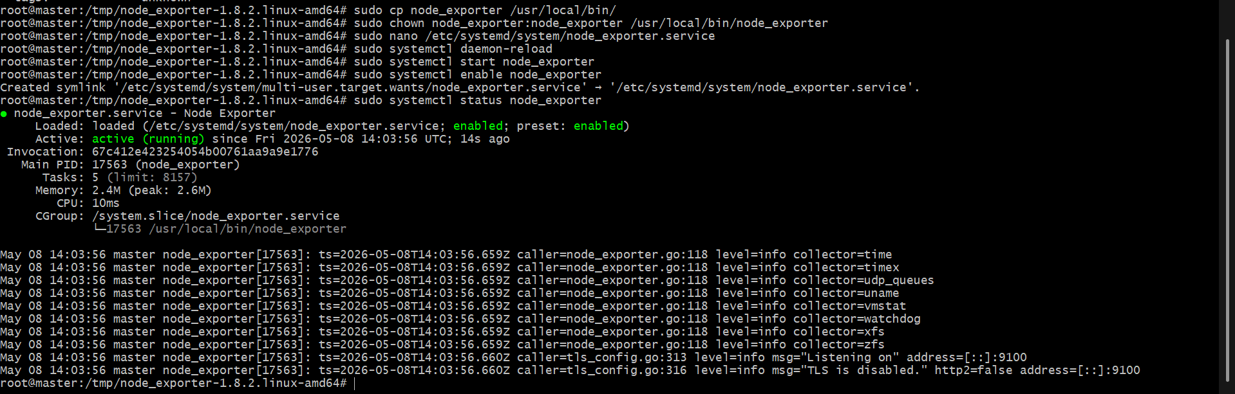

Step 8: Check browser
Open:
http://SERVER_PUBLIC_IP:9100/metrics
Example:
http://54.xx.xx.xx:9100/metrics
You should see metrics output.
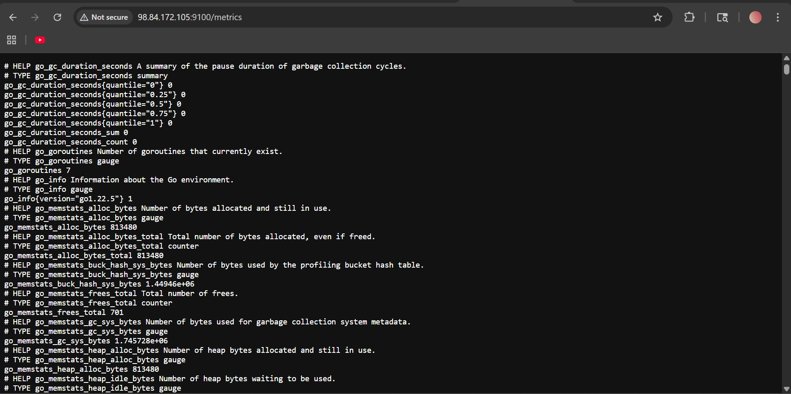

Step 9: Configure Prometheus
Open Prometheus config:
sudo nano /etc/prometheus/prometheus.yml
Replace with:
global:
scrape_interval: 15s
scrape_configs:
- job_name: "prometheus"
static_configs:
- targets: ["localhost:9090"]
- job_name: "node_exporter"
static_configs:
- targets: ["localhost:9100"]
Save:
CTRL + X
Y
ENTER

Step 10: Restart Prometheus
sudo systemctl restart Prometheus

Step 11: Verify targets
Browser:
http://SERVER_PUBLIC_IP:9090
Go to:
Status → Targets
You should see:
prometheus = UP
node_exporter = UP
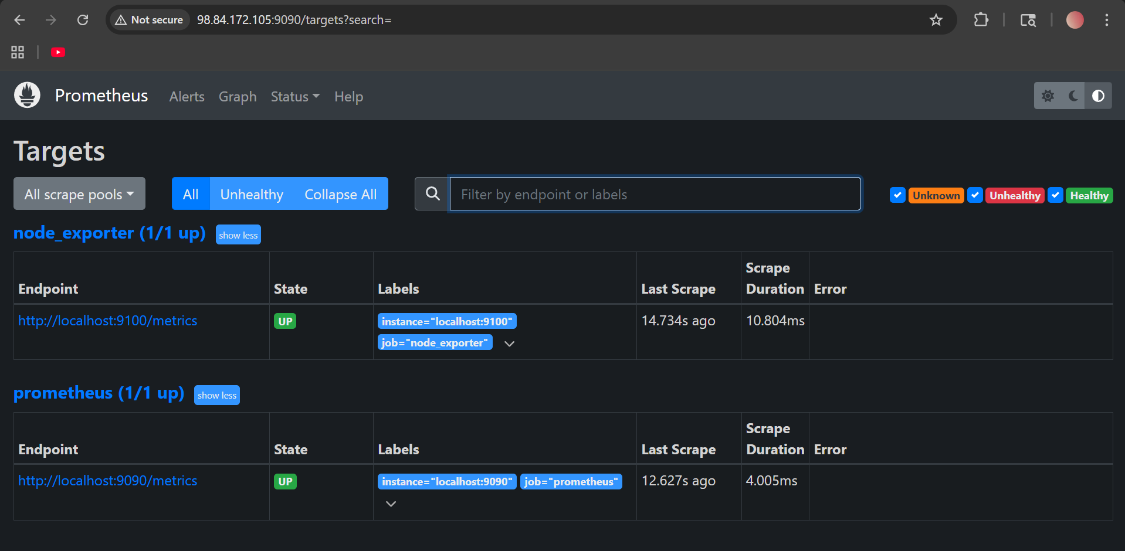

- Set up SNMP Exporter to monitor network devices.

Setup SNMP Exporter for Network Device Monitoring
SNMP Exporter is used to monitor:
- Routers
- Switches
- Firewalls
- Printers
- Network devices
Prometheus → SNMP Exporter → Network Device

Architecture
Prometheus ---> SNMP Exporter ---> Network Device

Step 1: Download SNMP Exporter
Go to /tmp
cd /tmp
Download:
wget https://github.com/prometheus/snmp_exporter/releases/download/v0.26.0/snmp_exporter-0.26.0.linux-amd64.tar.gz
Extract:
tar -xvf snmp_exporter-0.26.0.linux-amd64.tar.gz
Enter folder:
cd snmp_exporter-0.26.0.linux-amd64
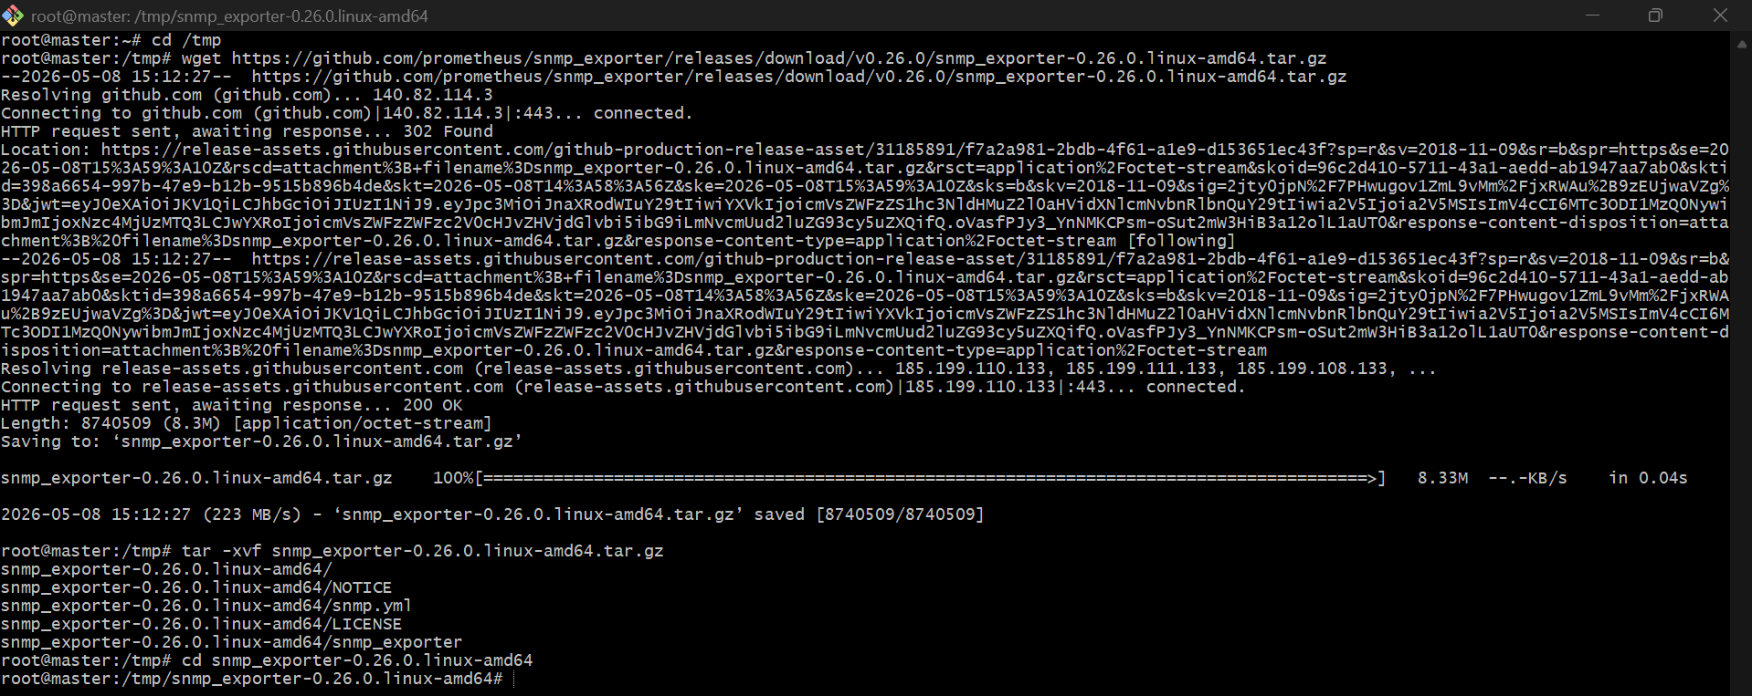

Step 2: Create user
sudo useradd --no-create-home --shell /bin/false snmp_exporter

Step 3: Copy files
Binary:
sudo cp snmp_exporter /usr/local/bin/
Create config directory:
sudo mkdir /etc/snmp_exporter
Copy config:
sudo cp snmp.yml /etc/snmp_exporter/
Permissions:
sudo chown -R snmp_exporter:snmp_exporter /etc/snmp_exporter
sudo chown snmp_exporter:snmp_exporter /usr/local/bin/snmp_exporter
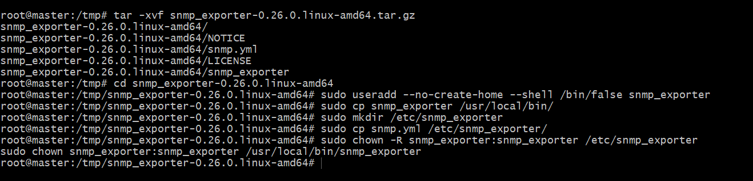

Step 4: Create service
sudo nano /etc/systemd/system/snmp_exporter.service
Paste:
[Unit]
Description=SNMP Exporter
Wants=network-online.target
After=network-online.target
[Service]
User=snmp_exporter
Group=snmp_exporter
Type=simple
ExecStart=/usr/local/bin/snmp_exporter \
--config.file=/etc/snmp_exporter/snmp.yml
[Install]
WantedBy=multi-user.target
Save:
CTRL + X
Y
ENTER

Step 5: Start service
Reload:
sudo systemctl daemon-reload
Start:
sudo systemctl start snmp_exporter
Enable:
sudo systemctl enable snmp_exporter
Check:
sudo systemctl status snmp_exporter
You should see:
active (running)
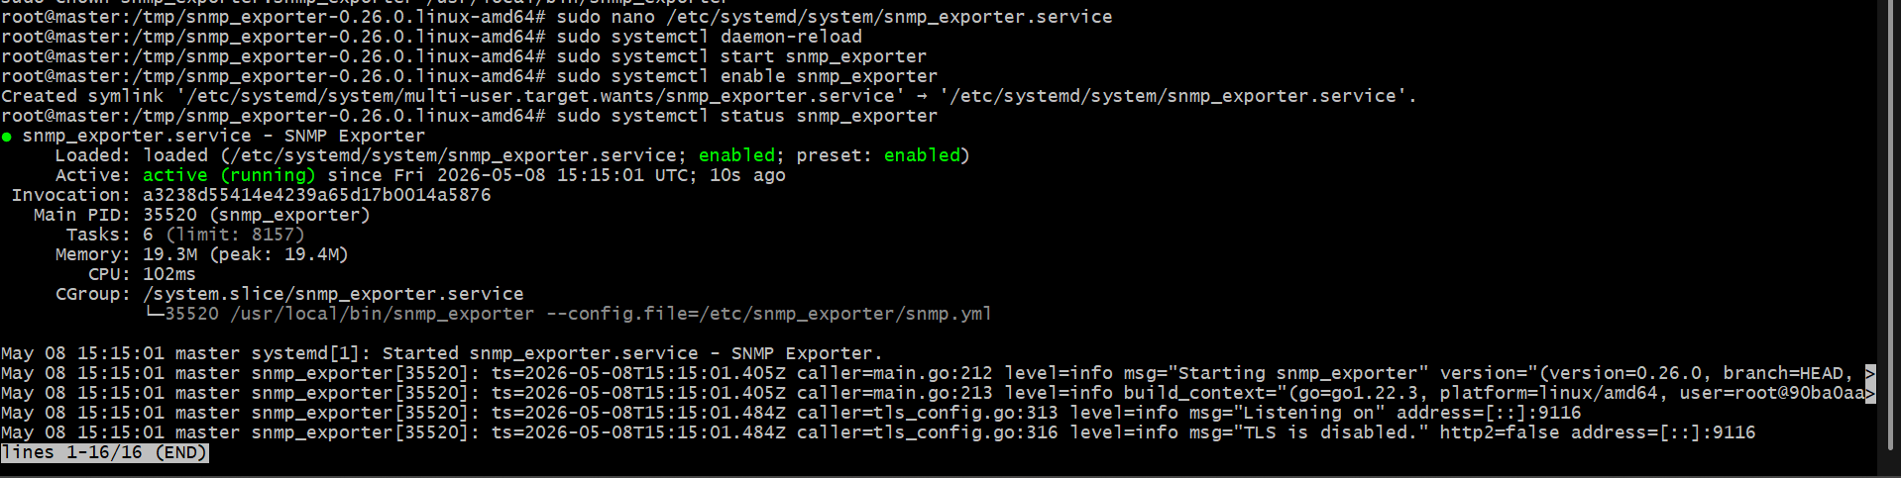

Step 6: Verify browser
Open:
http://SERVER_PUBLIC_IP:9116
You should see SNMP Exporter page.

Step 7: Configure Prometheus
Open config:
sudo nano /etc/prometheus/prometheus.yml
Add this below existing jobs:
- job_name: "snmp"
static_configs:
- targets:
- 192.168.1.1
metrics_path: /snmp
params:
module: [if_mib]
relabel_configs:
- source_labels: [__address__]
target_label: __param_target
- source_labels: [__param_target]
target_label: instance
- target_label: __address__
replacement: localhost:9116
Replace:
192.168.1.1
with your router/switch IP.

Step 8: Restart Prometheus
sudo systemctl restart prometheus

Step 9: Verify targets
Open:
http://SERVER_PUBLIC_IP:9090
Go:
Status → Targets
You should see:
snmp = UP

Step 10: Test metrics
In Prometheus Graph:
ifInOctets
or:
ifOutOctets
Then click:
Execute
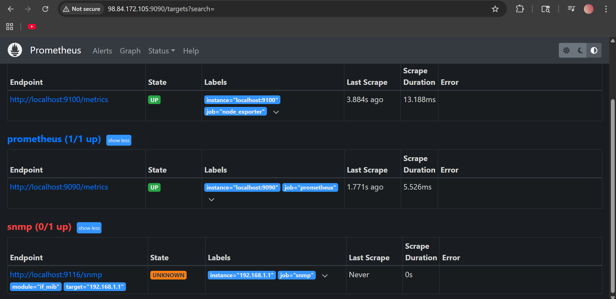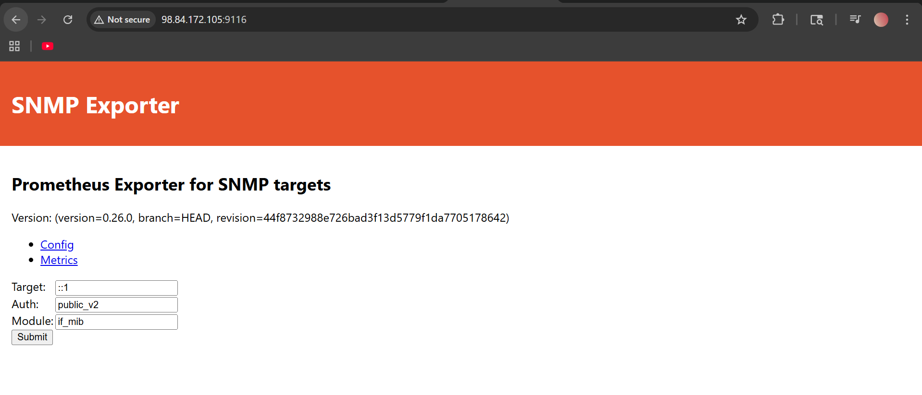

- Set up Prometheus to run as a systemd service for automatic startup.

Set Up Prometheus as a systemd Service
This allows:
- Automatic startup after reboot
- Service management using systemctl
- Background execution

Step 1: Create Prometheus service file
sudo nano /etc/systemd/system/prometheus.service
Paste:
[Unit]
Description=Prometheus
Wants=network-online.target
After=network-online.target
[Service]
User=prometheus
Group=prometheus
Type=simple
ExecStart=/usr/local/bin/prometheus \
--config.file=/etc/prometheus/prometheus.yml \
--storage.tsdb.path=/var/lib/prometheus \
--web.console.templates=/etc/prometheus/consoles \
--web.console.libraries=/etc/prometheus/console_libraries
[Install]
WantedBy=multi-user.target

Step 2: Save file
Press:
CTRL + X
Then:
Y
Then:
ENTER

Step 3: Reload systemd
sudo systemctl daemon-reload

Step 4: Start Prometheus
sudo systemctl start prometheus

Step 5: Enable automatic startup
sudo systemctl enable prometheus
Expected:
Created symlink ...

Step 6: Check service status
sudo systemctl status prometheus
You should see:
active (running)

Step 7: Verify automatic startup
Reboot server:
sudo reboot
After login:
sudo systemctl status prometheus
Prometheus should start automatically after reboot.

Step 8: Access Prometheus
Browser:
http://SERVER_PUBLIC_IP:9090
Example:
http://98.84.172.105:9090
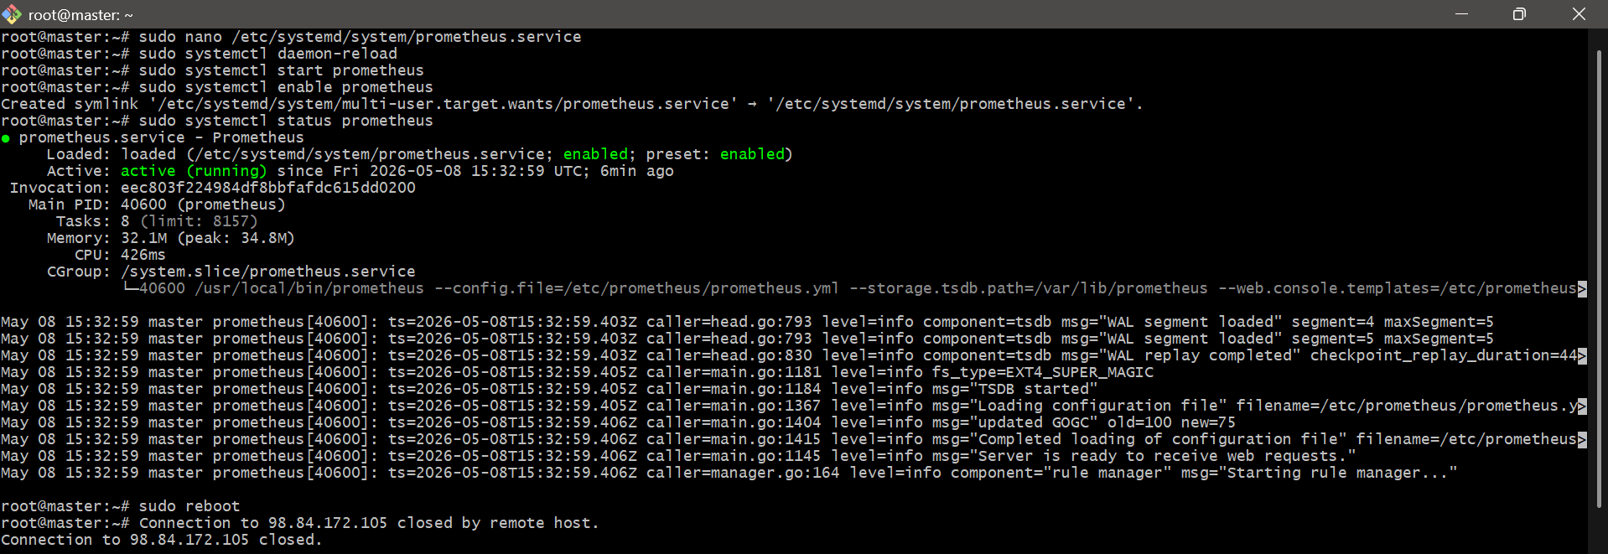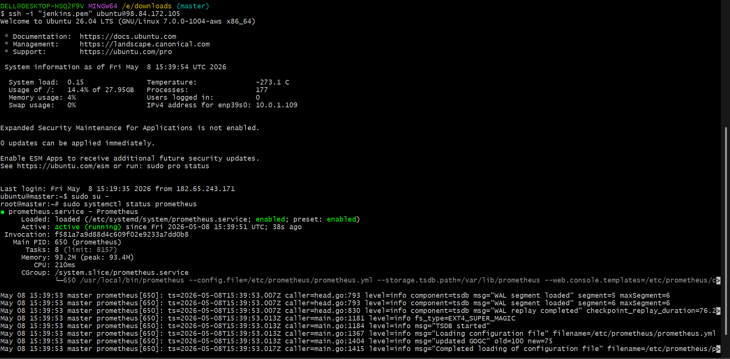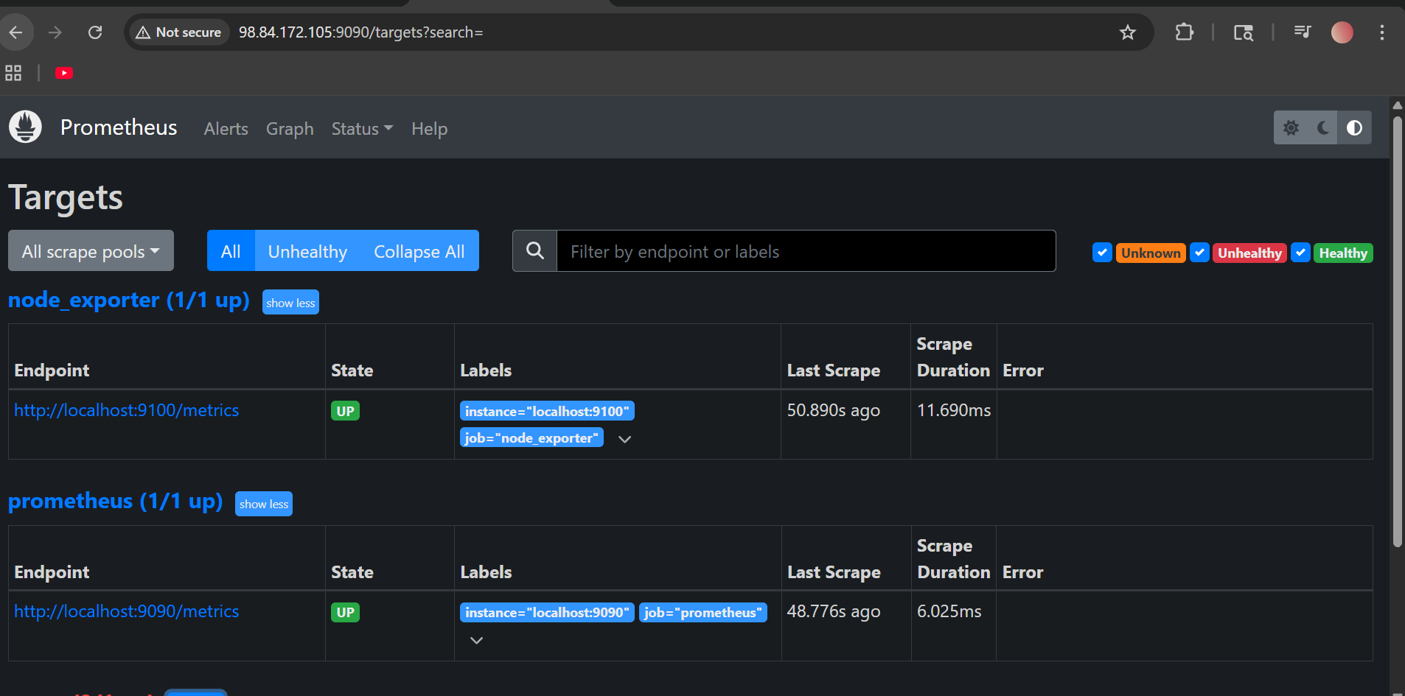

- Install Alertmanager and configure an email alert.

Install Alertmanager and Configure Email Alert
This setup will:
- Install Alertmanager
- Configure Prometheus alerts
- Send email notifications

Step 1: Create Alertmanager user
sudo useradd --no-create-home --shell /bin/false alertmanager

Step 2: Download Alertmanager
Go to /tmp
cd /tmp
Download:
wget https://github.com/prometheus/alertmanager/releases/download/v0.27.0/alertmanager-0.27.0.linux-amd64.tar.gz
Extract:
tar -xvf alertmanager-0.27.0.linux-amd64.tar.gz
Enter folder:
cd alertmanager-0.27.0.linux-amd64
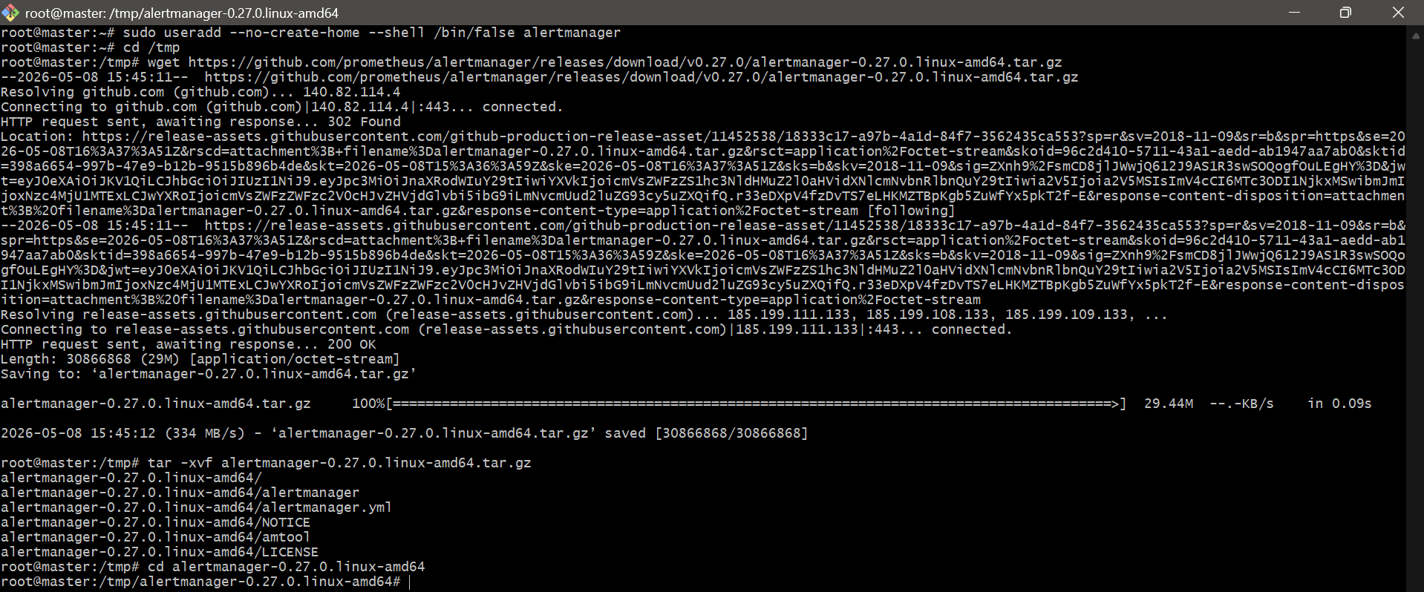

Step 3: Create directories
sudo mkdir /etc/alertmanager
sudo mkdir /var/lib/alertmanager

Step 4: Copy binaries
sudo cp alertmanager /usr/local/bin/
sudo cp amtool /usr/local/bin/
Permissions:
sudo chown alertmanager:alertmanager /usr/local/bin/alertmanager
sudo chown alertmanager:alertmanager /usr/local/bin/amtool

Step 5: Copy config
sudo cp alertmanager.yml /etc/alertmanager/
Permissions:
sudo chown -R alertmanager:alertmanager /etc/alertmanager
sudo chown -R alertmanager:alertmanager /var/lib/alertmanager

Step 6: Configure email alert
Open config:
sudo nano /etc/alertmanager/alertmanager.yml
Replace with:
global:
smtp_smarthost: 'smtp.gmail.com:587'
smtp_from: 'YOUR_GMAIL@gmail.com'
smtp_auth_username: 'YOUR_GMAIL@gmail.com'
smtp_auth_password: 'YOUR_APP_PASSWORD'
route:
receiver: 'email-alert'
receivers:
- name: 'email-alert'
email_configs:
- to: 'RECEIVER_EMAIL@gmail.com'
from: 'YOUR_GMAIL@gmail.com'
smarthost: 'smtp.gmail.com:587'
auth_username: 'YOUR_GMAIL@gmail.com'
auth_identity: 'YOUR_GMAIL@gmail.com'
auth_password: 'YOUR_APP_PASSWORD'

Step 7: Replace values
Replace:
YOUR_GMAIL@gmail.com
with your Gmail.
Replace:
YOUR_APP_PASSWORD
with Gmail App Password.
Replace:
RECEIVER_EMAIL@gmail.com
with destination email.

Step 8: Create systemd service
sudo nano /etc/systemd/system/alertmanager.service
Paste:
[Unit]
Description=Alertmanager
Wants=network-online.target
After=network-online.target
[Service]
User=alertmanager
Group=alertmanager
Type=simple
ExecStart=/usr/local/bin/alertmanager \
--config.file=/etc/alertmanager/alertmanager.yml \
--storage.path=/var/lib/alertmanager
[Install]
WantedBy=multi-user.target
Save:
CTRL + X
Y
ENTER

Step 9: Start Alertmanager
Reload:
sudo systemctl daemon-reload
Start:
sudo systemctl start alertmanager
Enable:
sudo systemctl enable alertmanager
Check:
sudo systemctl status alertmanager
You should see:
active (running)

Step 10: Configure Prometheus with Alertmanager
Open:
sudo nano /etc/prometheus/prometheus.yml
Add:
alerting:
alertmanagers:
- static_configs:
- targets:
- localhost:9093

Step 11: Create alert rules
Create rules file:
sudo nano /etc/prometheus/alert.rules.yml
Paste:
groups:
- name: test-alert
rules:
- alert: HighCPUUsage
expr: up == 0
for: 1m
labels:
severity: critical
annotations:
summary: "Instance Down"
description: "Prometheus target is down."

Step 12: Add rule file to Prometheus
Open:
sudo nano /etc/prometheus/prometheus.yml
Add:
rule_files:
- "alert.rules.yml"

Final prometheus.yml example
global:
scrape_interval: 15s
rule_files:
- "alert.rules.yml"
alerting:
alertmanagers:
- static_configs:
- targets:
- localhost:9093
scrape_configs:
- job_name: "prometheus"
static_configs:
- targets: ["localhost:9090"]
- job_name: "node_exporter"
static_configs:
- targets: ["localhost:9100"]

Step 13: Restart Prometheus
sudo systemctl restart prometheus

Step 14: Access Alertmanager
Browser:
http://SERVER_PUBLIC_IP:9093
Example:
http://98.84.172.105:9093

Step 15: Trigger alert
Stop Node Exporter:
sudo systemctl stop node_exporter
After 1 minute:
- Alert appears in Prometheus
- Email notification is sent
Start again:
sudo systemctl start node_exporter

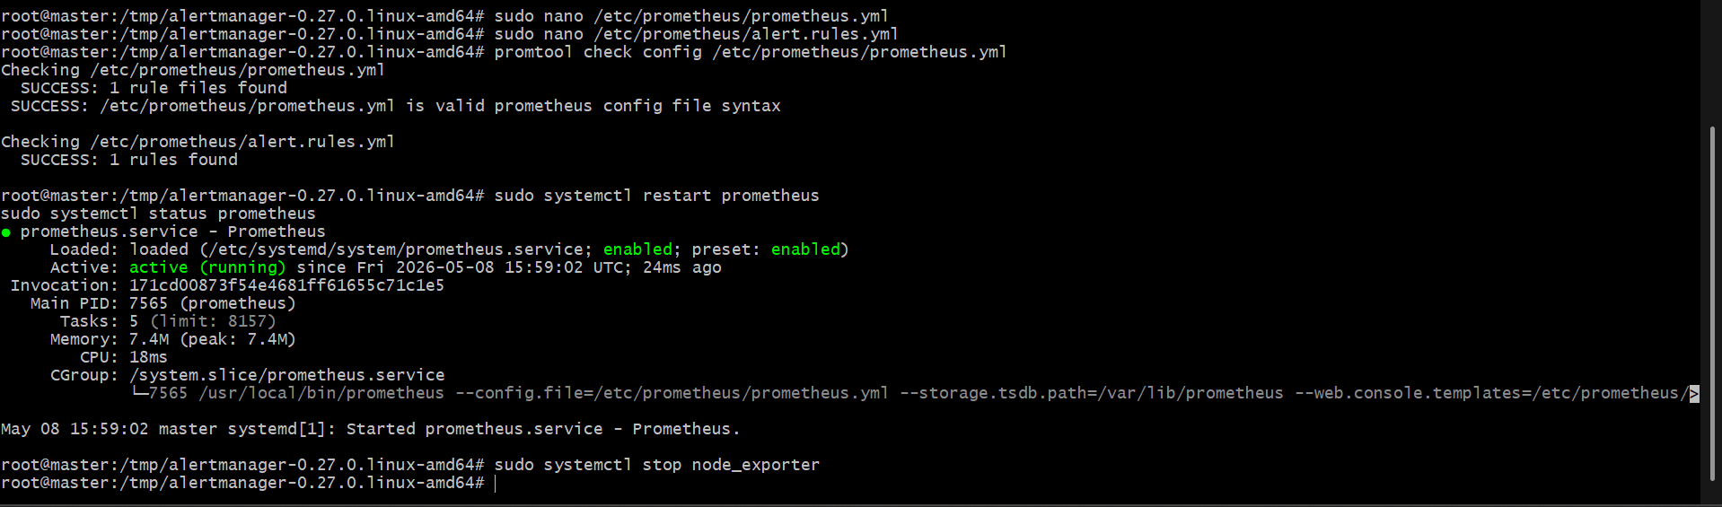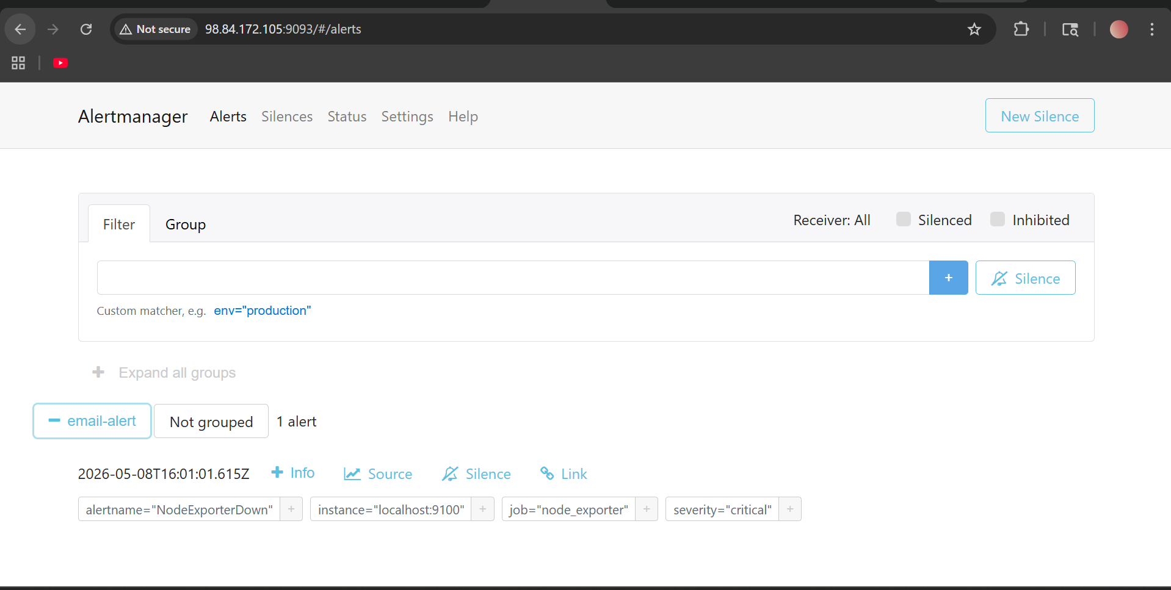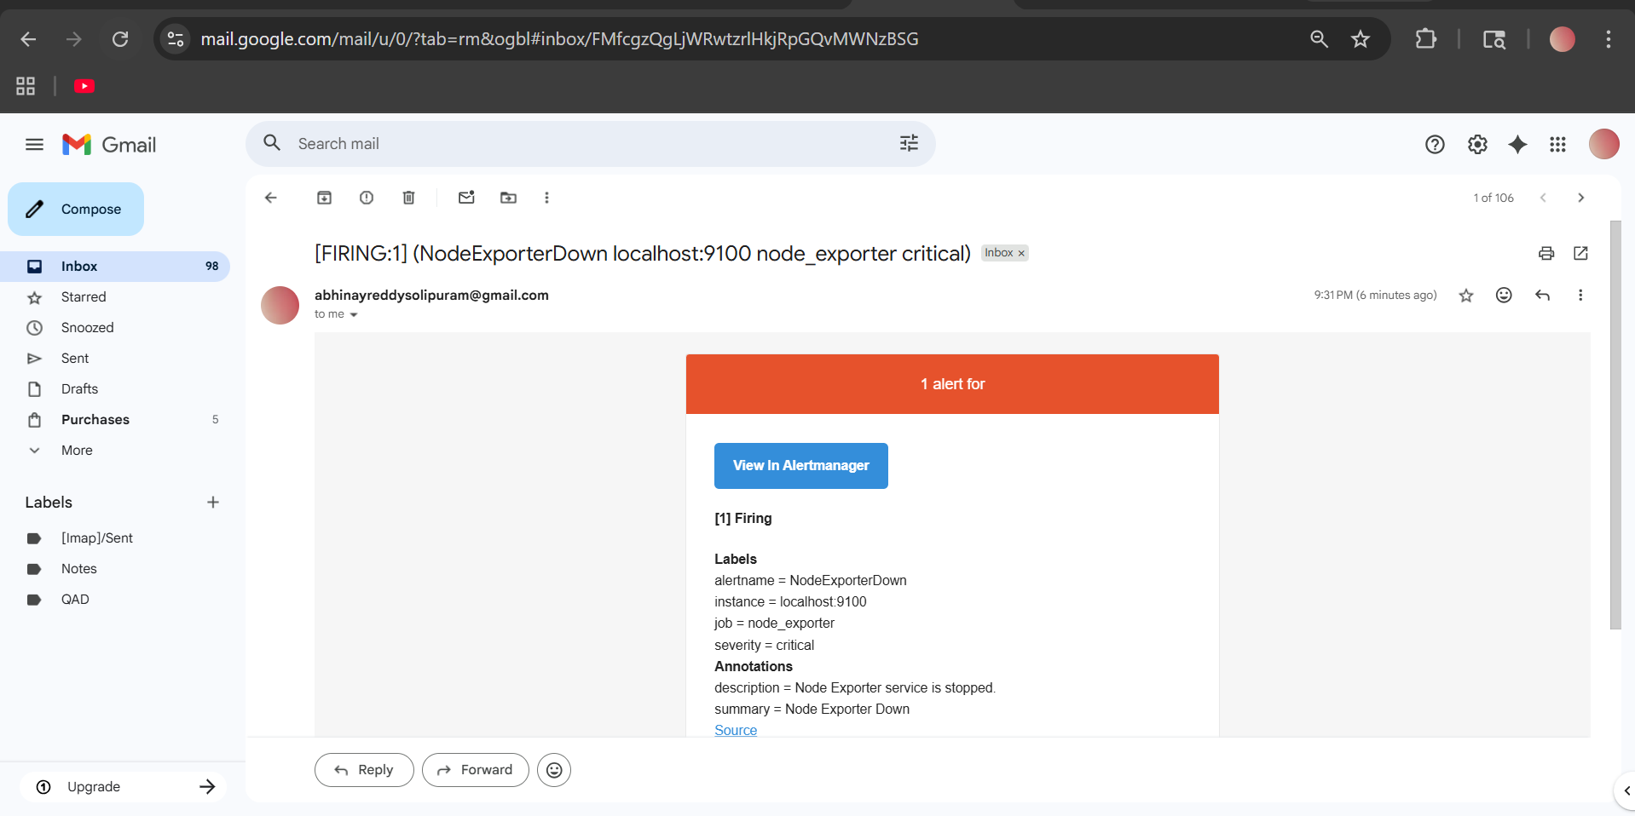

- Install Grafana and add Prometheus as a data source

Step 1: Update packages
sudo apt update -y
Install dependencies:
sudo apt install -y software-properties-common apt-transport-https wget 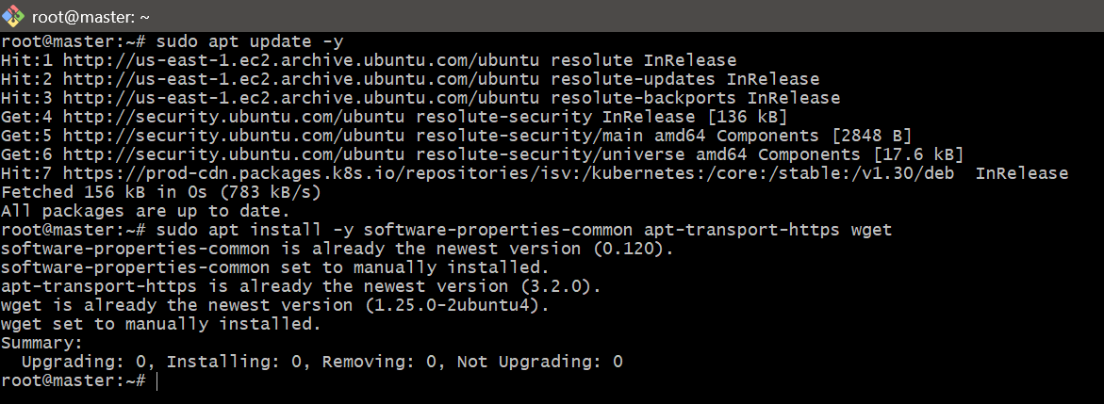

Step 2: Add Grafana GPG key
sudo mkdir -p /etc/apt/keyrings
wget -q -O - https://apt.grafana.com/gpg.key | \
gpg --dearmor | sudo tee /etc/apt/keyrings/grafana.gpg > /dev/null

Step 3: Add Grafana repository
echo "deb [signed-by=/etc/apt/keyrings/grafana.gpg] https://apt.grafana.com stable main" | \
sudo tee /etc/apt/sources.list.d/grafana.list
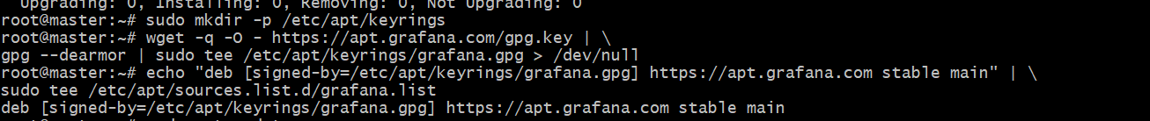

Step 4: Install Grafana
sudo apt update -y
sudo apt install grafana -y
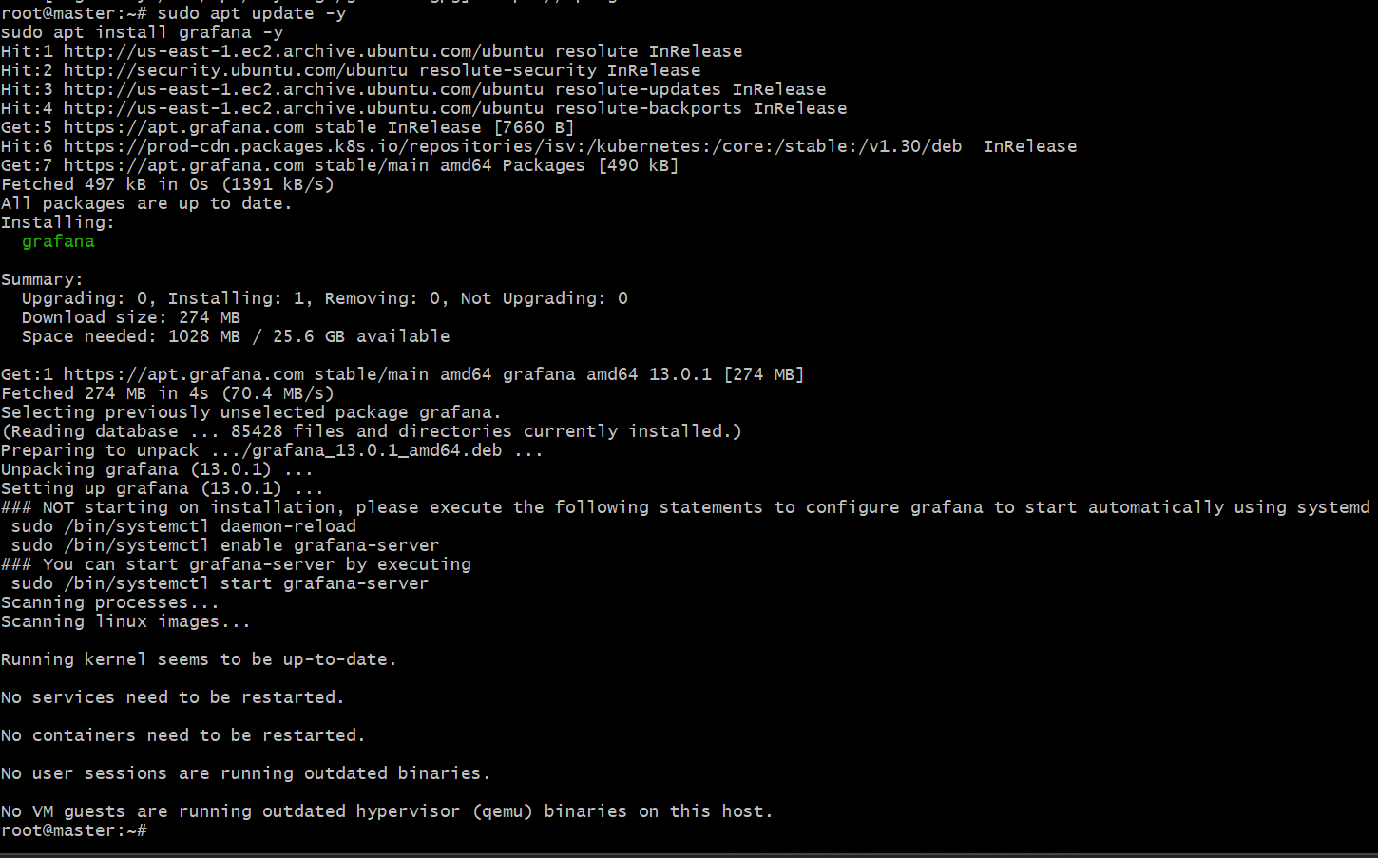

Step 5: Start Grafana
sudo systemctl daemon-reload
sudo systemctl start grafana-server
Enable auto startup:
sudo systemctl enable grafana-server
Check status:
sudo systemctl status grafana-server
You should see:
active (running) 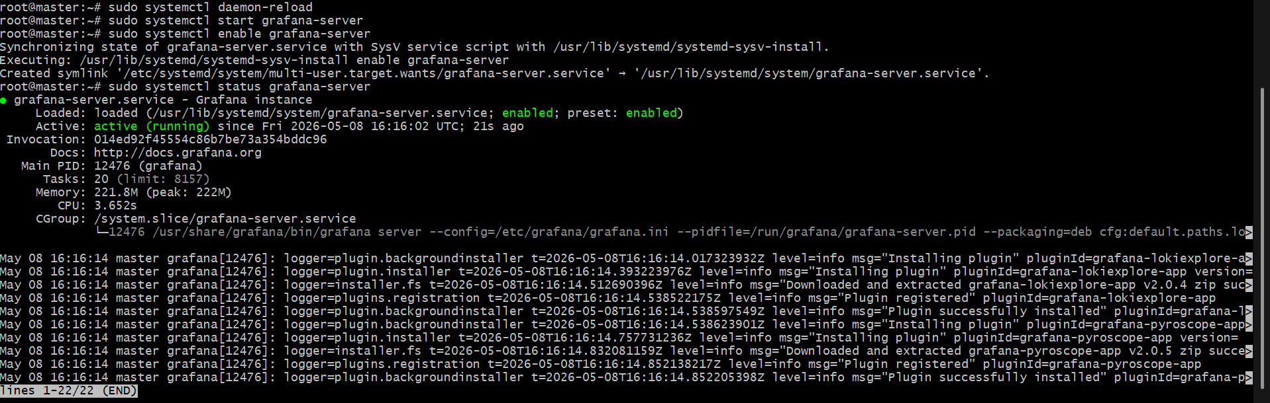

Step 6: Open Grafana port in AWS
Add inbound rule:
Custom TCP
Port: 3000
Source: My IP

Step 7: Open Grafana UI
Browser:
http://98.84.172.105:3000
Replace with your public IP.

Step 8: Login to Grafana
Default credentials:
Username: admin
Password: admin
Grafana asks for new password.
Set your new password. 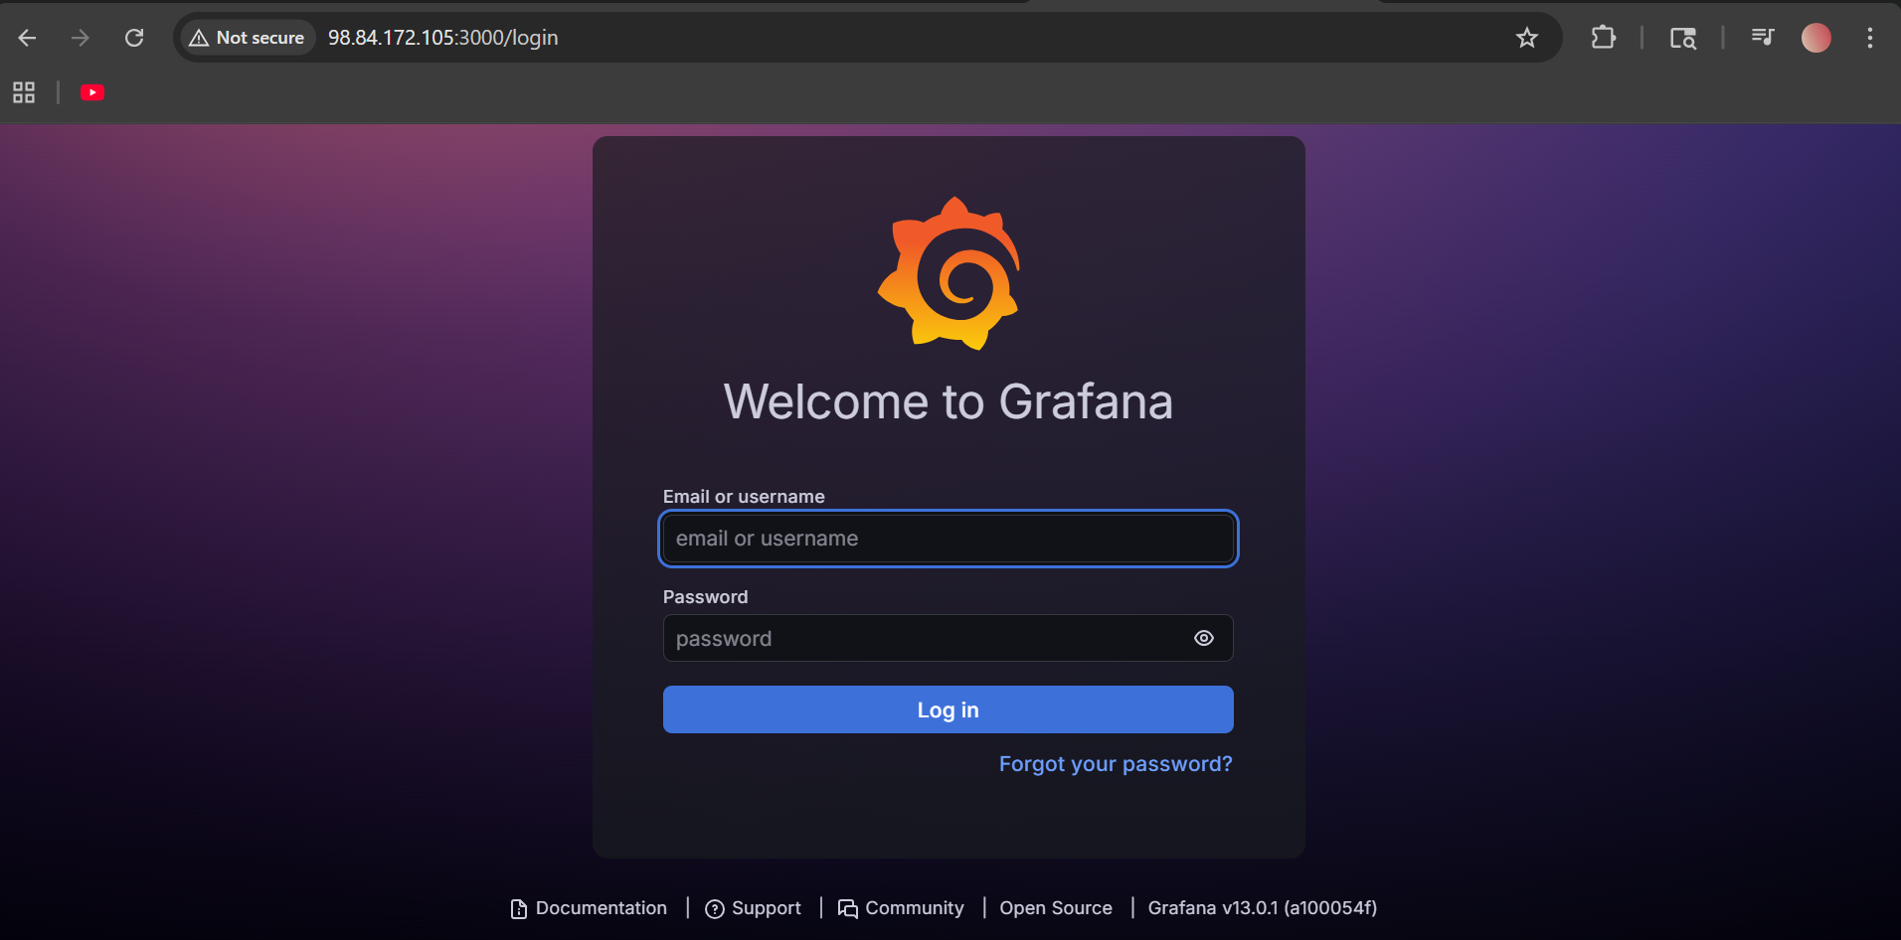

Step 9: Add Prometheus Data Source
In Grafana:
Click:
Connections → Data Sources
Click:
Add data source
Select:
Prometheus

Step 10: Configure Prometheus URL
Set URL:
http://localhost:9090
Scroll down.
Click:
Save & Test
Expected:
Data source is working

Step 11: Import Dashboard
Click:
Dashboards → Import
Dashboard ID:
1860
Click:
Load
Select Prometheus datasource.
Click:
Import

Final Result
You will see:
- CPU usage
- Memory usage
- Disk usage
- Network usage
- Server monitoring graphs
from Node Exporter metrics.
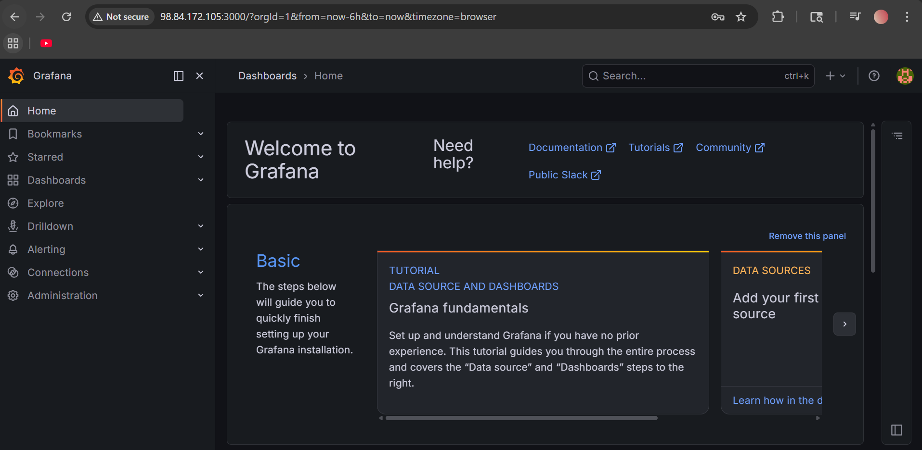

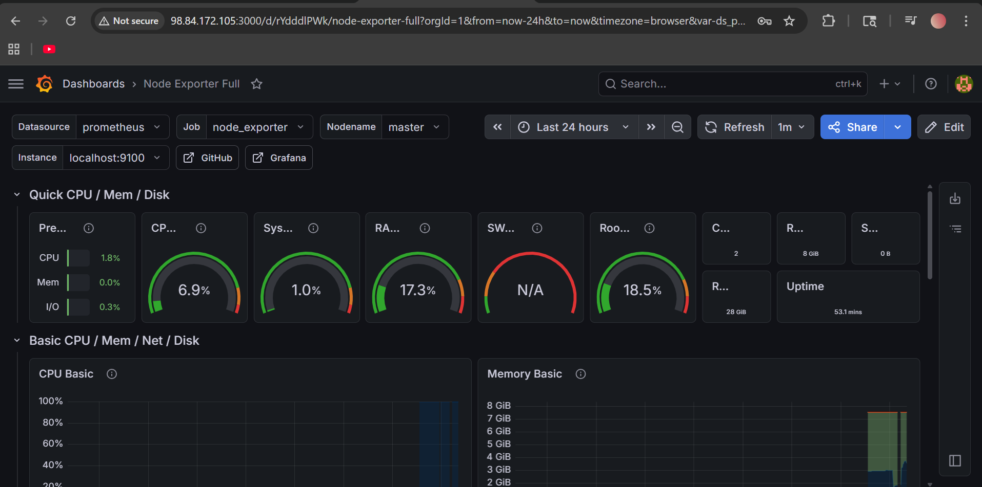
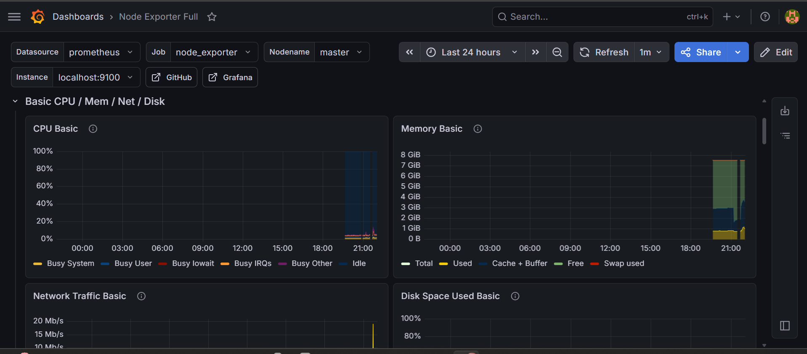

- Configure Prometheus for service discovery of dynamic targets.
Here is a simple file-based service discovery setup. This is best for dynamic targets because you can add/remove targets without editing main prometheus.yml.
1. Create targets folder
sudo mkdir -p /etc/prometheus/targets
2. Create target file
sudo nano /etc/prometheus/targets/node_targets.yml
Paste:
- targets:
- localhost:9100
labels:
job: node_exporter
environment: dev
Save:
CTRL + X
Y
ENTER

3. Update prometheus.yml
sudo nano /etc/prometheus/prometheus.yml
Use this config:
global:
scrape_interval: 15s
rule_files:
- "alert.rules.yml"
alerting:
alertmanagers:
- static_configs:
- targets:
- localhost:9093
scrape_configs:
- job_name: "prometheus"
static_configs:
- targets: ["localhost:9090"]
- job_name: "dynamic-node-targets"
file_sd_configs:
- files:
- /etc/prometheus/targets/*.yml
refresh_interval: 30s
Save:
CTRL + X
Y
ENTER
4. Check config
promtool check config /etc/prometheus/prometheus.yml
5. Restart Prometheus
sudo systemctl restart prometheus
6. Verify
Open:
http://98.84.172.105:9090/targets
You should see:
dynamic-node-targets UP

Add new dynamic target later
Edit only this file:
sudo nano /etc/prometheus/targets/node_targets.yml
Example:
- targets:
- localhost:9100
- 10.0.1.124:9100
- 10.0.1.38:9100
labels:
job: node_exporter
environment: dev
Prometheus will automatically reload targets within 30 seconds.

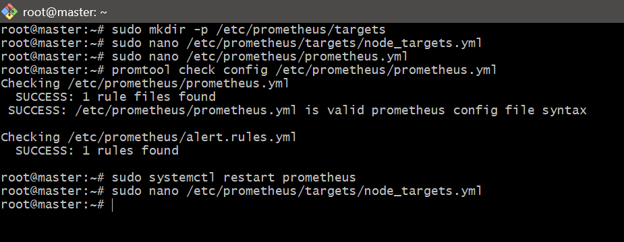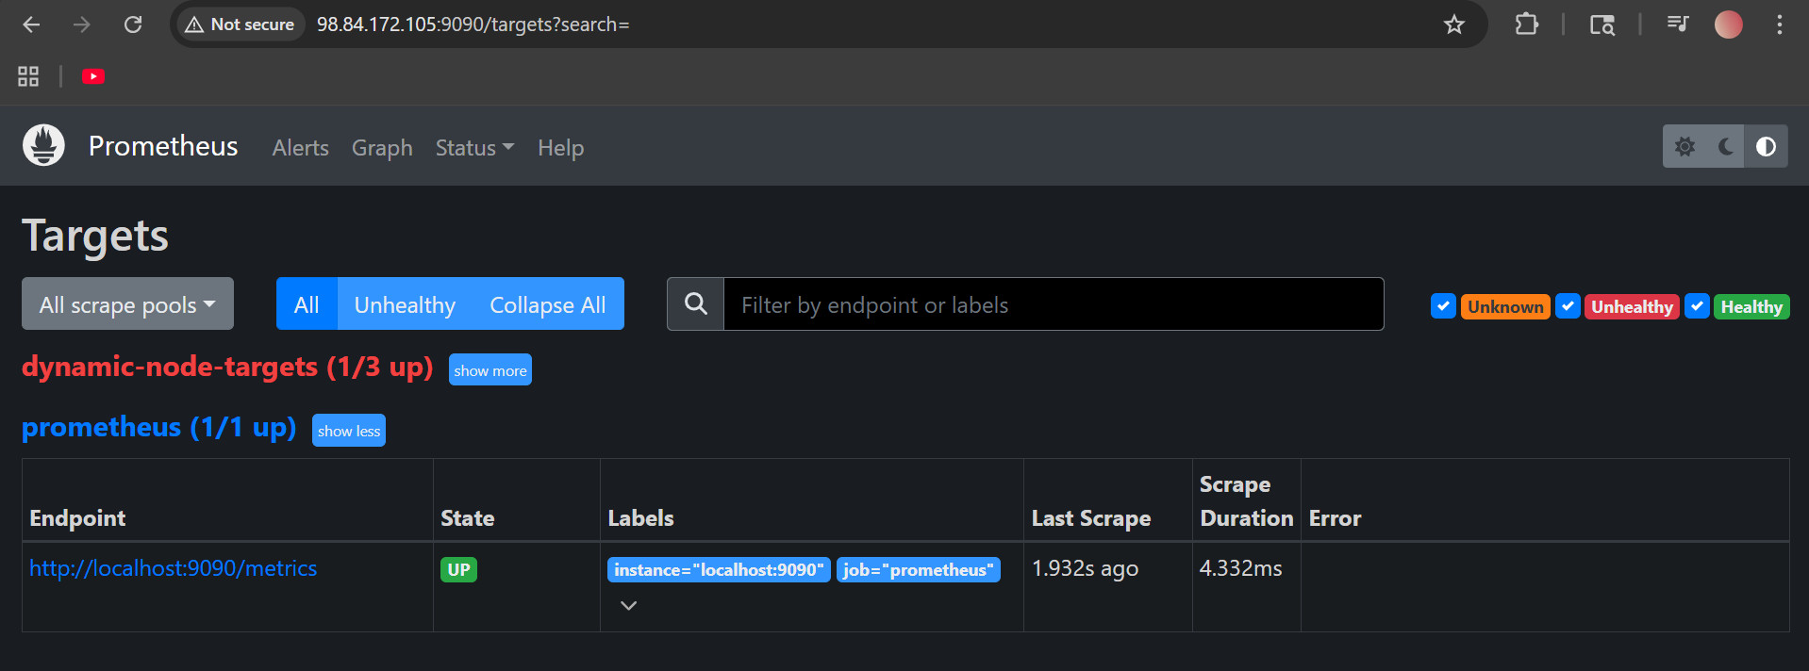

8. Create alerting rules for monitoring disk space.
1. Open alert rules file
sudo nano /etc/prometheus/alert.rules.yml
2. Add disk space alert rule
Paste this:
groups:
- name: disk-alerts
rules:
- alert: LowDiskSpace
expr: (node_filesystem_avail_bytes{fstype!="tmpfs",mountpoint!~"/run.*"} / node_filesystem_size_bytes{fstype!="tmpfs",mountpoint!~"/run.*"}) * 100 < 20
for: 2m
labels:
severity: warning
annotations:
summary: "Low disk space on {{ $labels.instance }}"
description: "Disk space is below 20% on mount point {{ $labels.mountpoint }}."
Save:
3. Check Prometheus config
promtool check config /etc/prometheus/prometheus.yml
4. Restart Prometheus
sudo systemctl restart prometheus
5. Verify alert
Open browser:
http://98.84.172.105:9090/alerts
You should see:
LowDiskSpace
If disk free space goes below 20%, alert will fire.
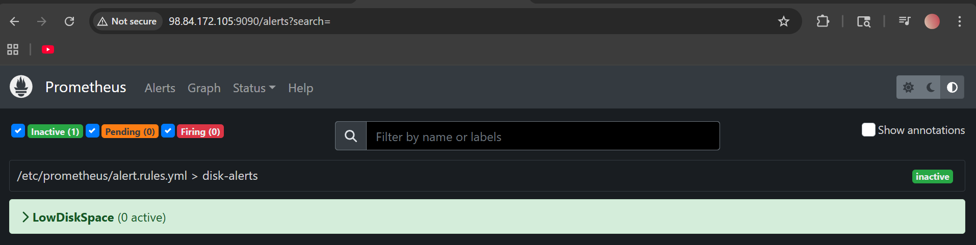

- Create a custom Grafana dashboard using Prometheus metrics for specific insights.

Custom Grafana Dashboard Using Prometheus Metrics
1. Open Grafana
http://98.84.172.105:3000
2. Create new dashboard
Go to:
Dashboards → New → New dashboard
Click:
Add visualization
Select datasource:
Prometheus

3. Add Panel 1: CPU Usage
Query:
100 - (avg by(instance) (rate(node_cpu_seconds_total{mode="idle"}[5m])) * 100)
Panel title:
CPU Usage %
Visualization:
Time series

4. Add Panel 2: Memory Usage
Query:
100 * (1 - (node_memory_MemAvailable_bytes / node_memory_MemTotal_bytes))
Panel title:
Memory Usage %
Visualization:
Gauge

5. Add Panel 3: Disk Usage
Query:
100 * (1 - (node_filesystem_avail_bytes{fstype!="tmpfs"} / node_filesystem_size_bytes{fstype!="tmpfs"}))
Panel title:
Disk Usage %
Visualization:
Gauge

6. Add Panel 4: Network Receive Traffic
Query:
rate(node_network_receive_bytes_total[5m])
Panel title:
Network Receive Bytes
Visualization:
Time series

7. Save dashboard
Click:
Save dashboard
Name:
Custom Server Monitoring Dashboard
Click:
Save
Now your custom Grafana dashboard shows CPU, memory, disk, and network insights from Prometheus metrics.
